# Memory Management, Pointers and References – Exercise

This document defines the exercises for the ["C++ Advanced" course @ Software University](https://softuni.bg/trainings/3658/cpp-advanced-may-2022). Please submit your solutions (source code) to all below-described problems in [Judge](https://judge.softuni.org/Contests/3014/CPlusPlus-Memory-Management-References-and-Pointers-Exercise).

## Gauss’ Trick

Write a program that **sums** all of the **numbers in a list** in the following order:

*first* ***+*** *last*, *first + 1* ***+*** *last - 1*,*first + 2* **+** *last* ***-*** *2***,** … *first + n*, *last - n*.

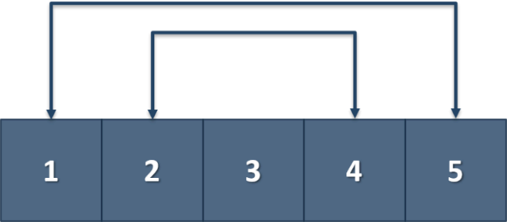

### Example

|  |  |
| --- | --- |
| **Input** | **Output** |
| 1 2 3 4 5 | 6 6 3 |
| 1 2 3 4 | 5 5 |

## Remove Negative and Reverse

Read a **list of integers**, **remove all negative numbers** from it and print the remaining elements in **reversed order**. In case there are no elements left in the list, print "empty".

### Examples

|  |  |
| --- | --- |
| **Input** | **Output** |
| 10 -5 7 9 -33 50 | 50 9 7 10 |
| 7 -2 -10 1 | 1 7 |
| -1 -2 -3 | empty |

## Print in Parts

Write a program that receives a 2-dimensional dynamic array with N rows and M columns and returns the first R rows and C columns.

**You are not allowed to use STL.**

### Example

|  |  |
| --- | --- |
| **Input** | **Output** |
| 3 4  1 2 3 4  11 22 33 44  111 222 333 444  3 3 | 1 2 3  11 22 33  111 222 333 |
| 4 4  2 2 2 2  5 6 7 8  0 1 0 2  9 7 5 3  2 4 | 2 2 2 2  5 6 7 8 |
| 4 4  2 2 2 2  5 6 7 8  0 1 0 2  9 7 5 3  4 2 | 2 2  5 6  0 1  9 7 |

## Some Ordering

Write a program that receives a string with N elements and returns two other strings – the first one is the same string with lower-case letters only, and the second one is the same string with upper-case letters only. Write the program with the help of pointers!

**You are not allowed to use STL.**

### Example

|  |  |
| --- | --- |
| **Input** | **Output** |
| I love Programming. | i love programming.  I LOVE PROGRAMMING. |
| Let’s go on a Vacation! | let's go on a vacation!  LET'S GO ON A VACATION! |
| Just Use POINTERS | just use pointers  JUST USE POINTERS |

## Compare Matrices

Write a program that reads two integer matrices (2D arrays) from the console and compares them element by element.   
**You are not allowed to use STL.**  
  
For better code reusability, you could do the comparison in a function, which returns **true** if they are equal and **false** if not.

Each matrix definition on the console will contain a line with a positive integer number **R** – the number of rows in the matrix – followed by R lines containing the numbers in the matrix, separated by spaces (each line will have an equal amount of numbers.

The matrices will have at most **10** rows and most **10** columns.

Print **equal** if the matrices match, and **not equal** if they do not match.

### Examples

|  |  |
| --- | --- |
| **Input** | **Output** |
| 1  1 2 3  1  1 2 3 | equal |
| 2  1 2 3  2 1 3  2  1 2 3  2 1 3 | equal |
| 4  1  11  21  31  4  1  11  21  31 | equal |
| 2  1 2 3  4 5 6  2  1 3 2  4 5 6 | not equal |
| 2  1 2 3  4 5 6  2  1 2  3 4 | not equal |

## Minesweeper

You are given an **N** by **M** matrix (**N** and **M** are two integers entered on the console), in which the cells contain single characters – either a **.** (dot) or a **!** (exclamation mark) – representing "empty" or "mined" positions.

Write a program that prints an N by M matrix, where each cell contains a number, representing how many adjacent cells, **including itself**, are "mined".

Each cell in a matrix has at most 8 adjacent cells – the cells directly above, below, to the left, to the right, as those diagonally – to the left and above, to the right and above, to the right and below and to the left and below.

**You are not allowed to use STL!**

### Examples

|  |  |  |  |  |  |  |  |
| --- | --- | --- | --- | --- | --- | --- | --- |
| **Input** | **Output** |  | **Input** | **Output** |  | **Input** | **Output** |
| 5 5  .....  ...!.  .....  .....  ..... | 00111  00111  00111  00000  00000 |  | 5 8  ........  ...!....  ....!...  ........  ...!.... | 00111000  00122100  00122100  00122100  00111000 |  | 3 3  !!!  !.!  !!! | 353  585  353 |